ALCOHOL TESTER
BRAND NAME - ALC SMART
MATERIAL TYPE – ALCOHOL TESTER
WARRANTY – NO WARRANTY IF DAMAGE OF BURNT

IMAGE :
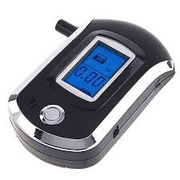
FEATURES :
- ADVANCED FLAT – SURFACED ALCOHOL SENSOR
- QUICK RESPONSE
- SMART MCU CONTROL
- DIRECT TESTING PROCESS LCD INDICATION
- DIGITAL LCD DISPLAY WITH LIGHT BLUE BACKUP
- PROTABLE AND FASHION DESIGN
- AUDIO WARNING PRE- SET LIMIT
- SENSOR FAULT SELF CHECKING
- BATTERY SAVED DESIGN, LOW VOLTAGE INDICATION
- APPLICABLE TO DRIVING AND DANGEROUS WORK

